Faculty of Engineering
School of Computer Science and Engineering Department of AIML



Project Report
Course code: AI4103, Recommender System
VII Semester, B.Tech. CSE(AIML)

Prepared by: Submitted to:
Sai Yashwant Reddy Panthy Mr. Harshit Sharma
219310192

Manipal University Jaipur
Dehmi Kalan, Off Jaipur-Ajmer Expressway, Jaipur, (Raj.),
Rajasthan 303007
1.Introduction
Today, customer reviews in social media have a deep impact on the chances of success of any business. Restaurant customers look for a complete and satisfactory experience regarding food quality, service, ambience and they often seek the opinion of patrons when they are choosing a place for their next meal. Yelp offers this information to its users. When users look for a place to eat, they can ask the service for a list of nearby restaurants for a cuisine category. Users also get the overall rating that other customers gave to the restaurant as well as some reviews about the restaurant.
Reviews content is very diverse. They can talk about the food, the service, the ambiance; they can reflect a positive experience or a complain about some specific aspect of their experience. Therefore, reviews are a wealth of information and usually are more informative than a numeric rating. On the other hand, a service like Yelp receives thousands of reviews each day from every corner of the world and summarizing or extracting specific pieces of information from such a big corpus is a challenging task.
Data mining and more concretely text mining techniques allow us to explore a massive corpus like the one of Yelp reviews. We can obtain new insights about the text content that may be helpful for customers, restaurant owners, government or even for Yelp.
In this project, we mine a corpus of Yelp restaurant reviews to explore the next questions: What are the best restaurants in a city? How many different cuisines restaurants serve? Can we recommend dishes for a cuisine and which restaurant is best to try them? This problem is made easier for users by recommendation systems which utilize their personal preferences to suggest best restaurant according to their preferred cuisine.

2. Problem Statement
The project is designed in a manner to search for and recommend best restaurants in a city for different kinds of cuisines based on reviews given by customers.
3. Objectives
- To predict rating of restaurants listed in the Yelp dataset based on the reviews given by the users. Classification techniques such Support Vector Machines are used.
- Recommending restaurants to the users using the predicted stars and sentiment polarity values.
- Graphical User Interface which particularly takes two inputs from user or customers to predict ten best restaurants available in a particular city for a particular cuisine provided by customer.
4. Data Description
The data used in this project is part of the Yelp Dataset Challenge (Round 12). The dataset consists of a set of JSON files that include business information, reviews, tips (shorter reviews), user information and check-ins. Business objects list name, location, opening hours, category, average star rating, the number of reviews about the business and a series of attributes like noise level or reservations policy. Review objects list a star rating, the review text, the review date, and the number of votes that the review has received. In this project, we have focused on these two types of objects. The data consists of six sub datasets which describes the data with a brief information
- The size of the Data is 6.84 Gb including the sub files
  - Business Dataset (139 MB)
  - Check-In Dataset (50.3 MB)
  - Photo Dataset (34.9 MB)
  - Review Dataset (4.39 GB)
  - Tips Dataset (203 MB)
  - Users Dataset (2.03 GB)
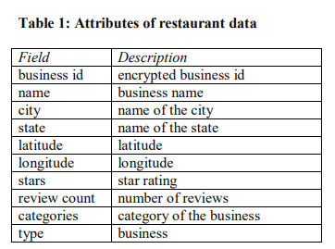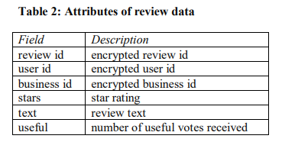
5. Related Work:
Due to the rich information contained in the Yelp dataset, many past research and projects tried to use it to predict ratings of restaurants and to evaluate the future development. For example, Kong, Nguyen and Xu classified restaurants based on cultural categories and analyzed international restaurants success mostly with Gaussian Discriminant Analysis (GDA). Several other previous papers focused on the sentiment analysis with text content from Yelp. Xu, Wu and Wang combined the customer reviews and ratings together to conduct sentiment analysis, while Gingerich and Bochkov mainly used matrix factorization to analyze text information and predict Yelp ratings. Linshi worked on user-based text analysis on Yelp rating prediction. He showed that how Yelp user experience can be improved from rating prediction. Other than Yelp review, Tang, Qin, Liu and Yang introduced neural network to predict movie reviews. They claimed that matrix-vector multiplication would be more effective than vector concatenation when considering text analysis. So far, most research works on text analysis of customer reviews, but leaves out other features in Yelp Dataset Challenge. In this project, we apply non-text features to predict restaurants ratings and aims to work on a region-based analysis instead of a user-based analysis in order to provide suggestions to Yelp restaurants.
6. Methodology:
We aim to build a recommendation system that will enable us to make sophisticated restaurant recommendations for Yelp users. We begin by providing a brief explanation of the dataset we used while creating our recommendation system. We follow this with a relevant exploratory analysis of data. 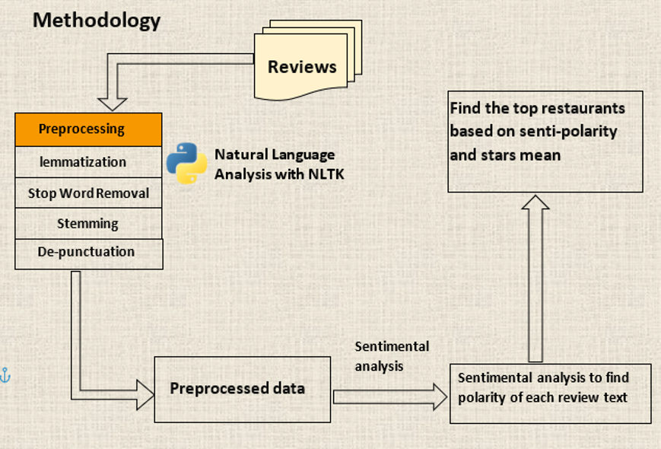
Fig (6.0.1): Methodology flow diagram
6.1 Exploratory Analysis:
The primary features of a business being used in our data analysis are business category and location (state and city). The preliminary exploratory analysis of the dataset includes study of distribution of reviews with respect to category of the business and its location.
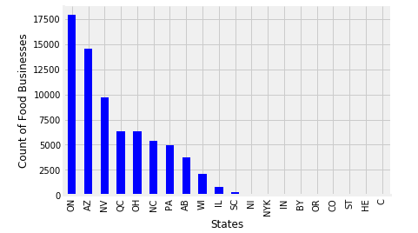
Fig (6.1.1): Frequency distribution of State v/s Number of food businesses
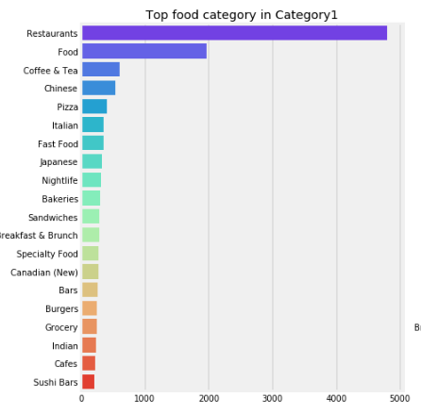
Fig (6.1.2): Frequency distribution of categories v/s count

6.2 Dataset Reduction:
After exploratory analysis, we trimmed our dataset only for Ontario state consisting of food related categories.
We selected instances with:
● Business category as ‘Restaurants’, ’Food’, ’Japanese’, ’Chinese ‘, ‘Thai’, ’Italian’, ’Indian’.
● State as ‘Ontario’ (ON)

6.3 Predictive Tasks:
There are two major tasks in our project:
● Predicting rating from the review text alone.
● Recommending restaurants based on predicted stars and sentiment polarity.

6.4 Predicting rating from the review text, we implemented the following the model:
● Linear Support Vector Machine Classifier
6.4.1 Linear Support Vector Machine Classifier:
Support Vector Machine (SVM) is primarily a classifier method that performs classification tasks by constructing hyperplanes in a multidimensional space that separates cases of different class labels. SVM is effective in high dimensional spaces. It uses a subset of training points in the decision function (called support vectors), so it is also memory efficient. And different kernel functions can be specified for the decision function. In this project, we use the open python library scikit-learn to implement the classifier.

To build a Linear SVM Classifier using the reviews text, we carried out the following preprocessing steps:
● Removed the punctuations
● Removed the stop words
The classifier needs some sort of feature vector in order to perform the classification task. We used the TF.IDF feature to convert the review text into vector format. So, each review is now represented as a set of coordinates in a high-dimensional space. During training, the SVM will try to find some hyperplanes that separate our training examples. When we feed it the test data, it will use the boundaries it learned during training to predict the rating of each test review.

7. Discussion Predicting Ratings:
Evaluation Metrics We use Precision and Recall as the evaluation metric to measure our rating prediction performance. SVM has better performance than Naïve Bayes, as a naive Bayes classifier simply assumes that the value of a particular feature is unrelated to the presence or absence of any other feature, given the class variable. SVM on the other hand is primarily a classier method that performs classification tasks by constructing hyperplanes in a multidimensional space that separates cases of different class labels. Tf.idf with bigrams is performing better. These results are intuitively aligned to the observation that we need to factor in phrases like ‘not great’, ‘not bad’ to understand the sentiment of the review.
8. Code:
Our code is divided into three parts:
- Exploratory analysis of datasets
- Predicting ratings from review text and calculating sentiment polariy
- Recommendation of restaurants.
PREDICTING RATINGS
RECOMMENDATION

ANALYSIS OF DATASETS

8.1 Linear Support Vector Machine Classifier Python Notebook
- Pre-processed the review text by removing the stop words using NLTK and removed the punctuations.
- Converted the review text into vector format using TF-IDF approach using the TfidfVectorizer in sklearn.
- Split the dataset into train and test set (80:20) using train-test split of sklearn.
- Built a linear SVM model and fitted it to our training set.
- Evaluated the model for 5 classes (1,2,3,4,5-star rating)

8.2 Restaurant recommender python notebook
- Calculating the sentiment polarity for each business.
- Considering the rows having stars value greater than 3.5 and sentiment polarity values greater than 0.
- Obtaining the top 10 restaurants with highest sentiment polarity.

8.3 Result:
Model | Feature | Precision | Recall | Accuracy | Number of Classes
Linear SVM | Bigram + TF-IDF | 0.590484199818 | 0.596285137787 | 0.596285137787 | 5

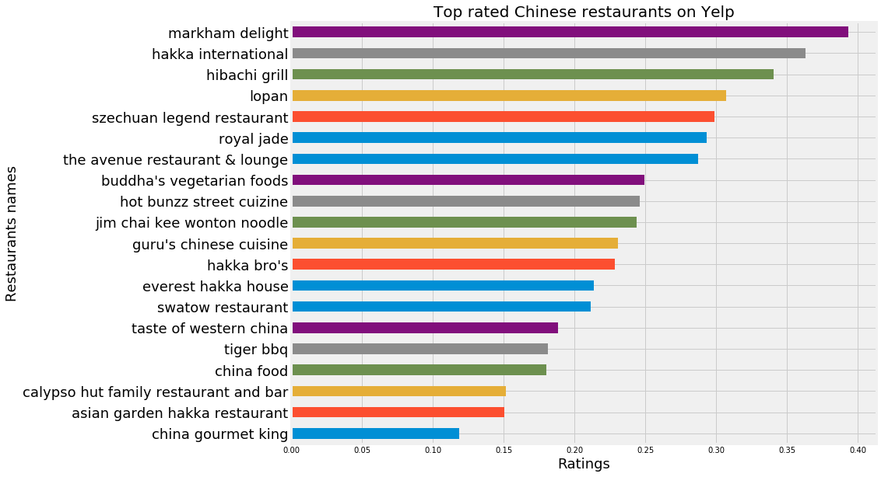

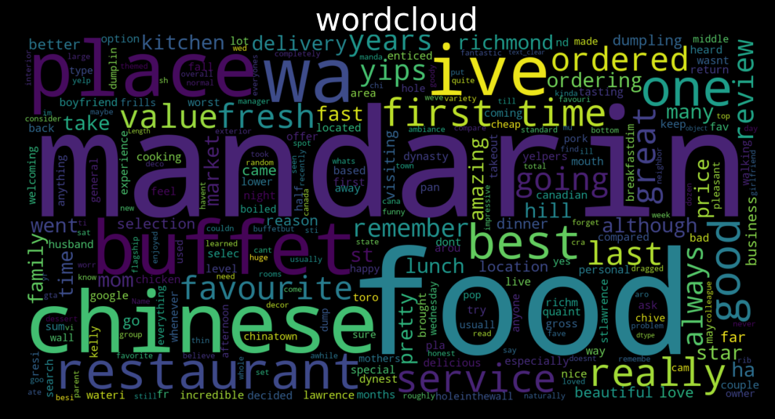
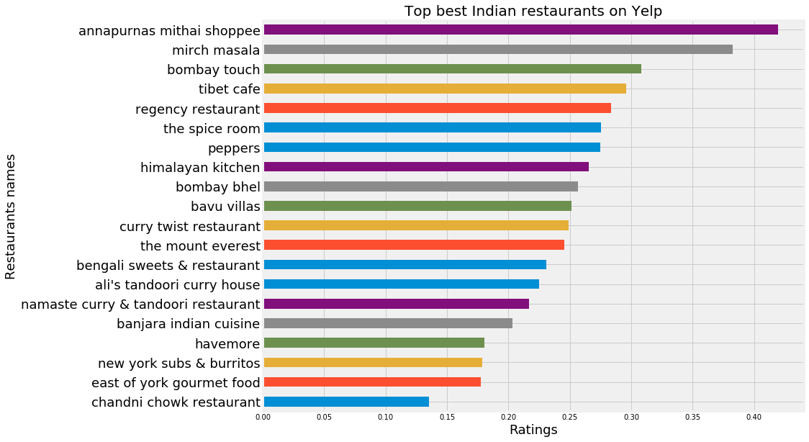
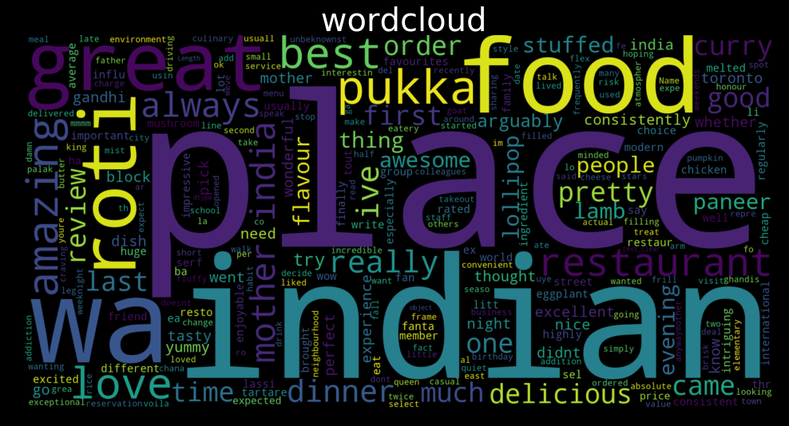

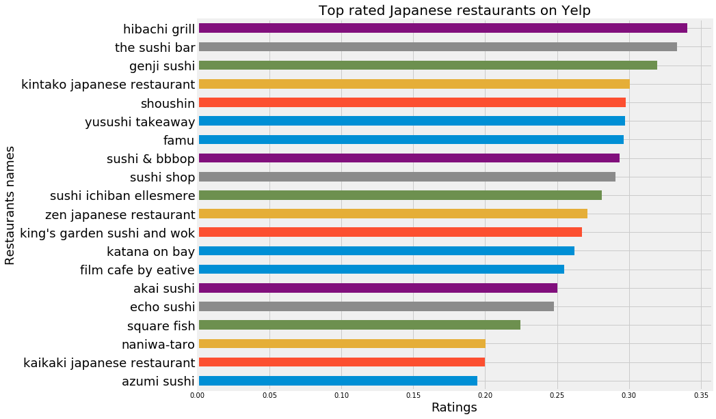
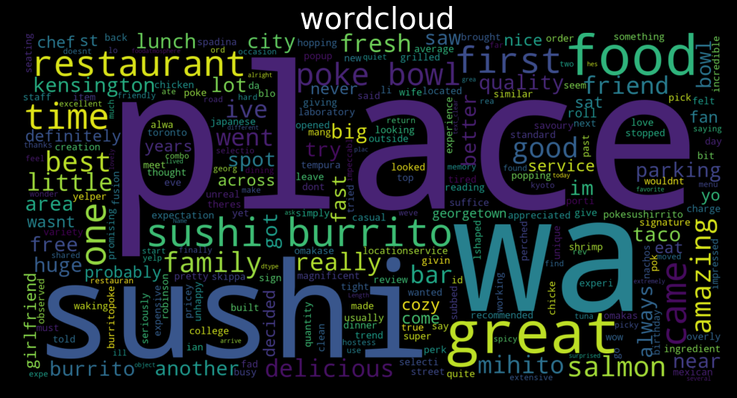

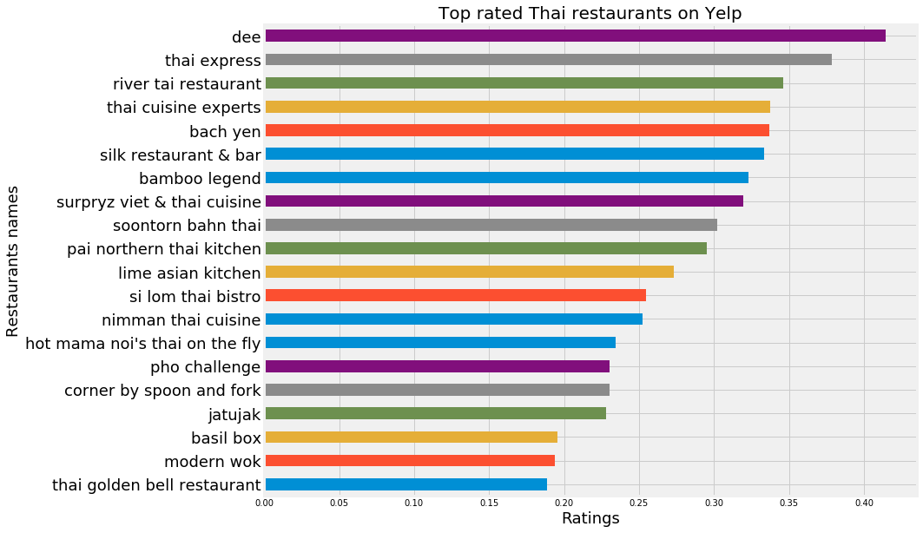
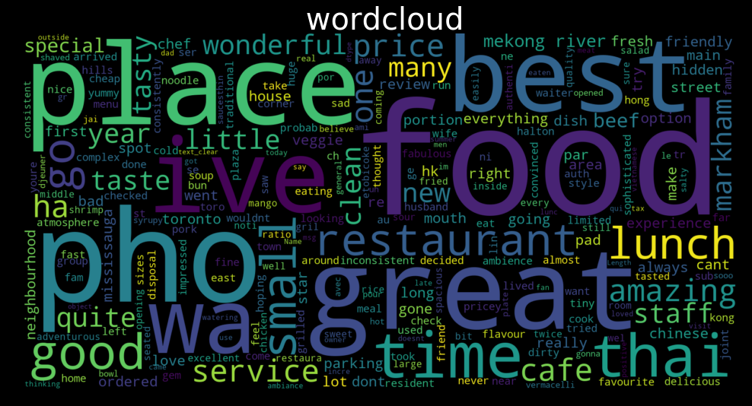

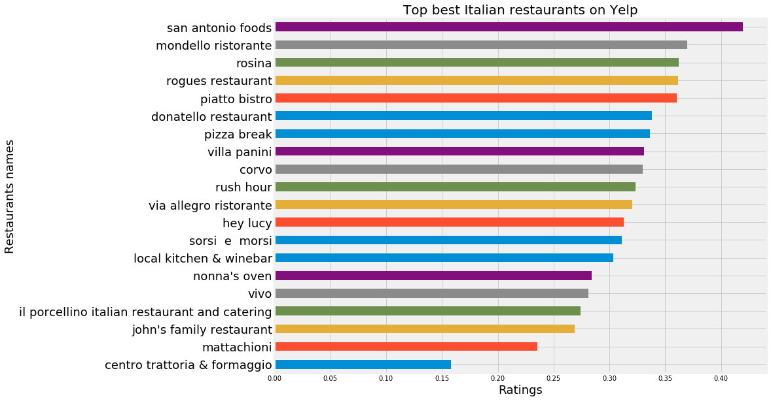

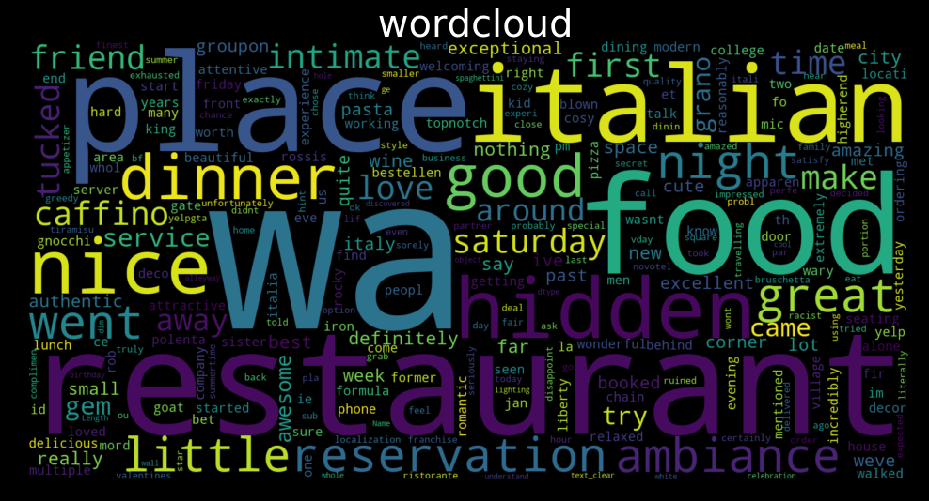

9. References:
[1] Yelp Challenge Presentation: http://www.ics.uci.edu/~vpsaini
[2] http://www.ics.uci.edu/~vpsaini/files/technical_report.pdf
[3] Scaria, Aju Thalappillil, Rose Marie Philip, and Sagar V. Mehta. “Predicting Star Ratings of Movie Review Comments.”
[4] https://cseweb.ucsd.edu/~jmcauley/cse255/reports/fa15/017.pdf
[5] Chada, Rakesh, and Chetan Naik. “Data Mining Yelp Data Predicting rating stars from review text.”
[6] Li, Chen, and Jin Zhang. “Prediction of Yelp Review Star Rating using Sentiment Analysis.”
[7] https://nycdatascience.com/blog/student-works/yelp-recommender-part-1/
[8] https://cambridgespark.com/content/tutorials/implementing-your-own-recommender-systemsin-Python/index.html
[9] Arun Babu, Rahool Arun Paliwal and Syamsankar Kottukkal. “Content-Aware Collaborative Filtering for Yelp Restaurant Recommendation

